Familiarization of ARM 7 LPC2148 STARTER KIT
The ARM7 LPC2148 starter kit is based on a 32/16 Bit ARM7TDMI-s CPU with real time Emulation and Embedded Trace support, That combines with the microcontroller with embedded high speed 512KB flash memory. It can work with 16-bit Thumb Mode.
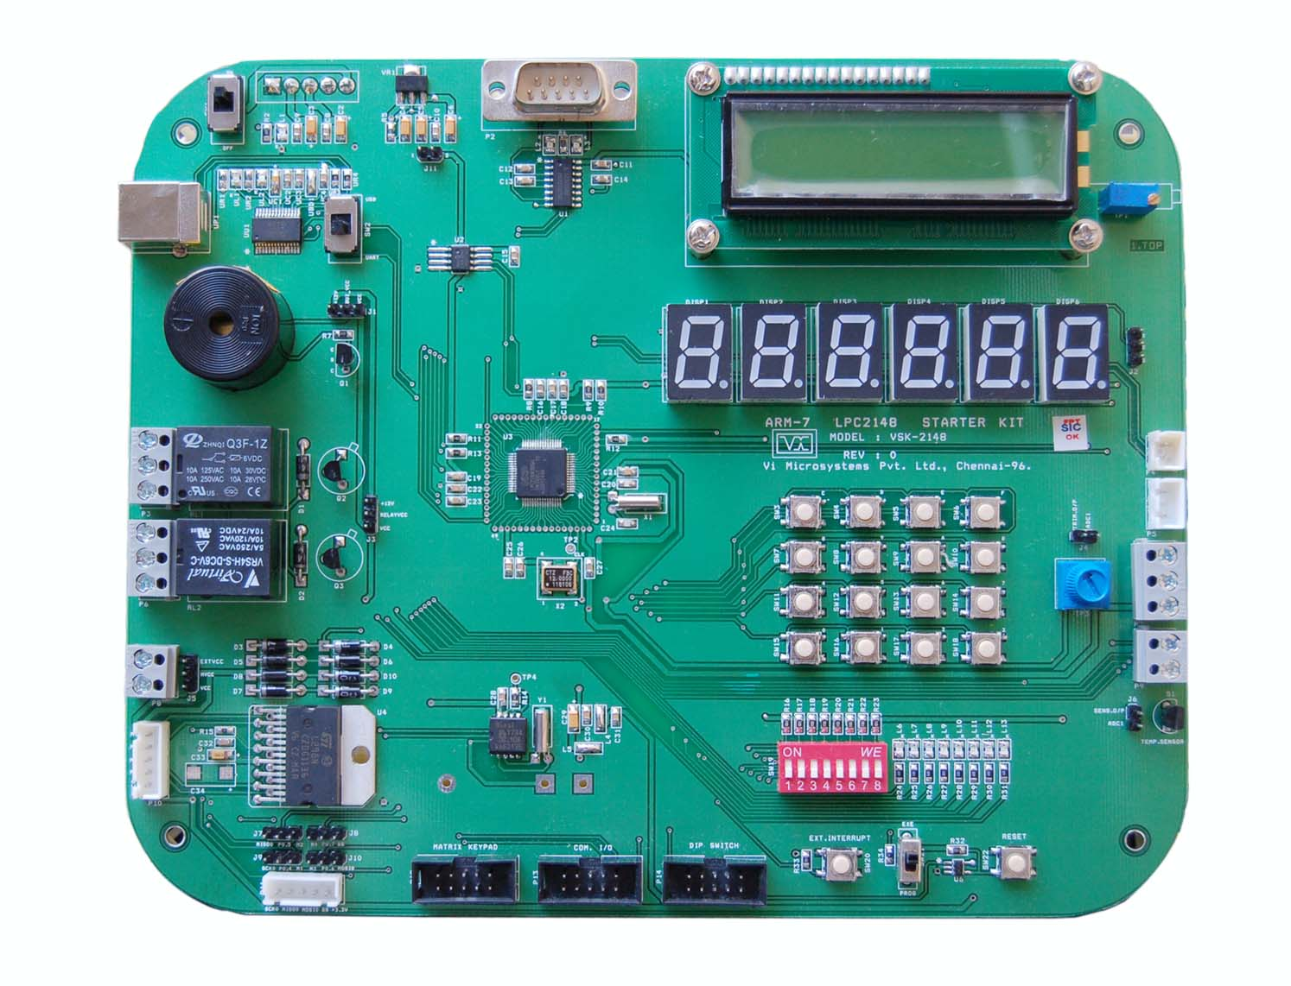
With Useful Implemented peripherals, plentiful practical code examples and a broad set of additional on board. VSK-2148 board make fast and reliable tools that can satisfy the needs of experienced engineers and beginners alike.
VSK-2148 Boards achieve their small size through Modern SMD technology and Multilayer Design. All Controller signals and ports extend from the controller to high density pitch Connectors of the board.
VSK-2148 Hardware Manual Describes the board’s design and functions. Precise Specifications for the NXP LPC2148 Microcontroller can be found in the enclosed Microcontroller Data sheet/User’s Manual. In this hardware manual, schematic diagrams and Block Diagrams are attached.
IAR EMBEDDED WORKBENCH
The IAR Embedded Workbench® IDE is a very powerful Integrated Development Environment, that allows you to develop and manage complete embedded application projects. It is a development platform, with all the features you would expect to find in your everyday working place.
The IDE is the framework where all necessary tools are seamlessly integrated:

* The highly optimizing IAR C/C++ Compiler

* The IAR Assembler

* The versatile IAR ILINK Linker, including accompanying tools

* A powerful editor

* A project manager

* A command line build utility

* IAR C-SPY® Debugger, a state-of-the-art high-level language debugger.
CREATING THE NEW PROJECT IN EWARM-5.4 KICKSTART VERSION
CREATING THE NEW PROJECT
IAR Embedded Workbench Installation is completed , Shortcut ICON is placed at your desktop. Just make an double click on that ICON. New Window is open as given below.



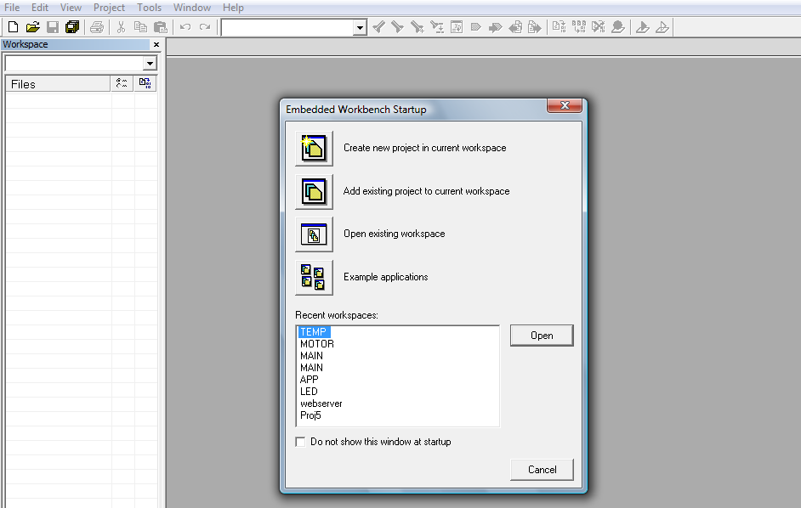
- To create a new project, choose Project>Create New Project. The Create New Project dialog box appears, which lets you base your new project on a project template.
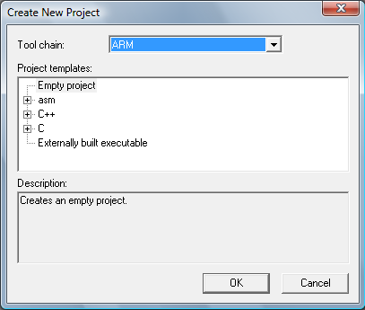

- Make sure the Tool chain is set to ARM, and click OK.
- Select the project template Empty project, and click ok button. Which simply creates an empty project that uses default project setting.
- In the standard Save As dialog box that appears, specify where you want to place your project file, that is, in your newly created projects directory. Type your project name in the File name box, and click Save to create the new project. eg. LED.
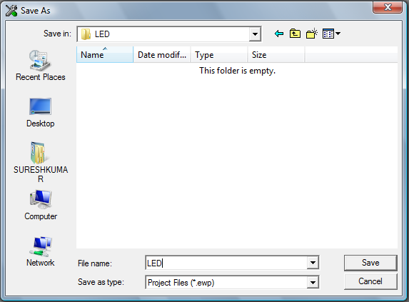
The project will appear in the Workspace window.
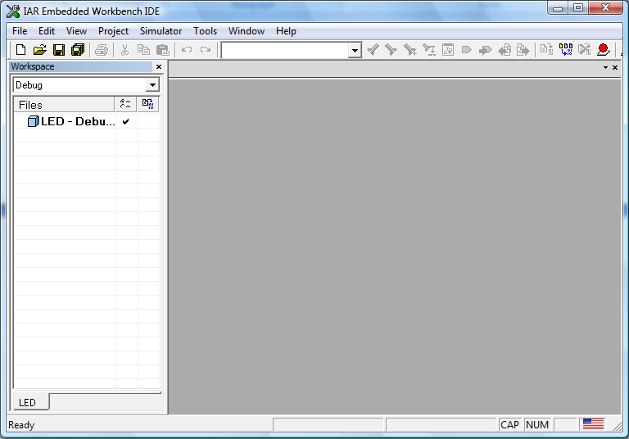
To Creating your Application ‘C’ file, Choose FILE menu and select NEW>File.
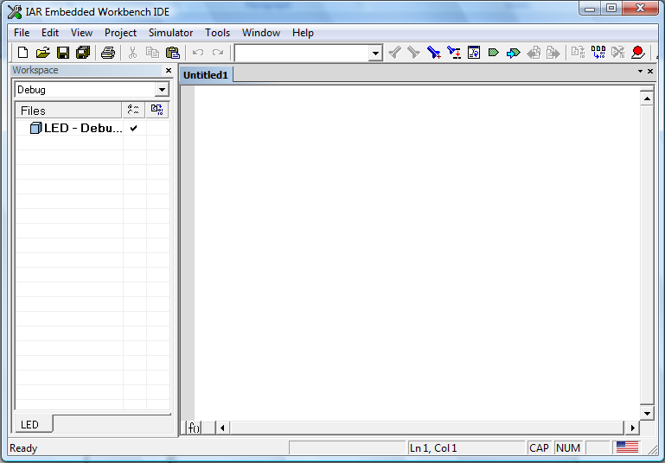
Edit the application code in C Language . Eg. Led.c
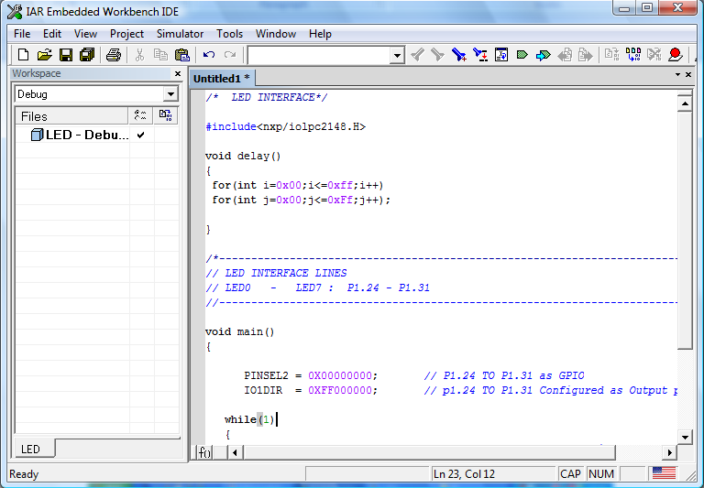
To Save your ‘C’ file, Choose File>Save As. In the standard Save As dialog box that appears, specify where you want to place your project file, that is, in your project directory. Type your filename in the File name box, and click Save to create the new project. Eg. Led.c
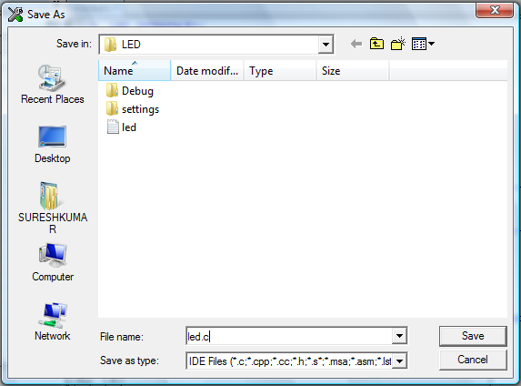

ADDING FILES TO THE PROJECT
1. In the Workspace window, select the destination to which you want to add a source file; a group or, as in this case, directly to the project.
2. Choose Project>Add Files to open a standard browse dialog box. Locate the files led.c select them in the file selection list, and click Open to add them to the project1 project.
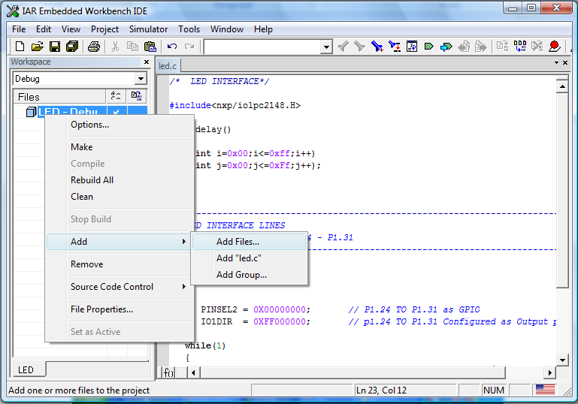

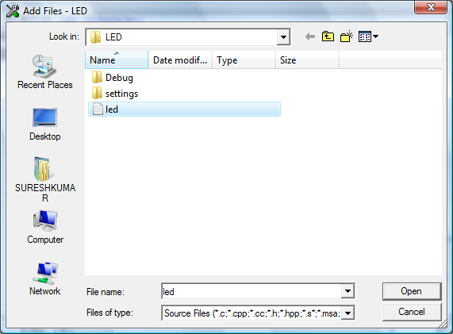
To save your work space, Choose File>Save Workspace and specify where you want to place your workspace file. In this tutorial, you should place it in your newly created project directory. Type LED in the File name box, and click Save button.
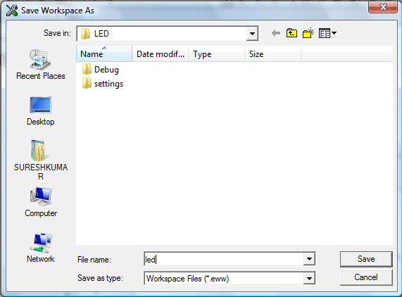

SETTING PROJECT OPTIONS
Now you will set the project options. For application projects, options can be set on all levels of nodes. First you will set the general options to suit the processor configuration in this tutorial. Because these options must be the same for the whole build configuration, they must be set on the project node.
1. Select the project folder icon LED - Debug in the Workspace window and choose Project>Options. Then select Output Converter in the Category list to display the linker option pages.
The Output options are used for specifying details about the output format and the level of debugging information included in the output file.
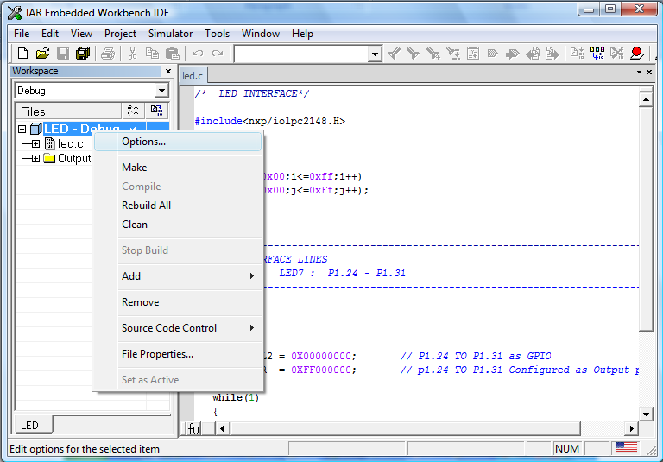
Select “option” on the popup menu. After selecting popup menu window shows as given below.
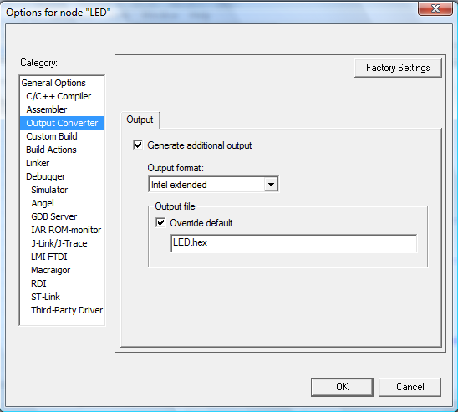

Select output format as “ Intel Extended”, output file in the format of .hex format.

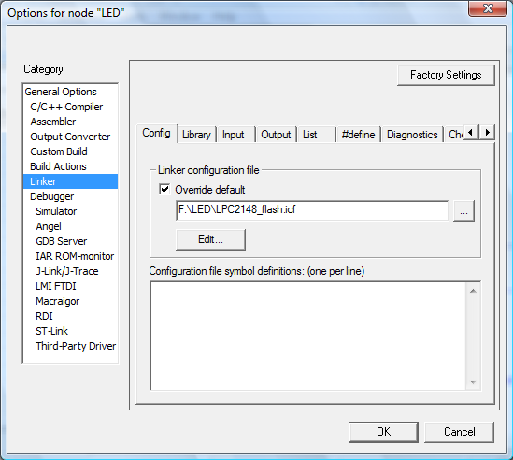
Select the linker file menu, linker configuration file available at project directory.
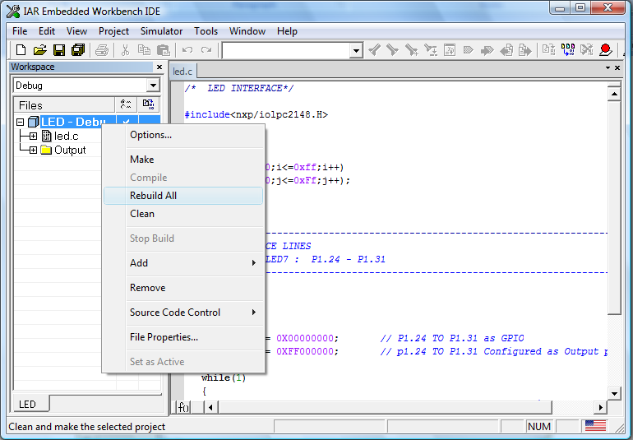
To Compile your Project, Choose Project>Rebuild ALL

If your project has no error Building completed and Hex file generated
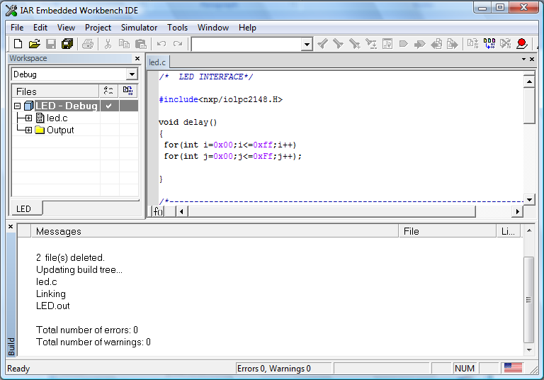

HARDWARE DETAILS
About VSK-2148 CPU
The LPC2148 microcontrollers are based on a 32/16 bit ARM7TDMI-S CPU with real-time emulation and embedded trace support, that combines the microcontroller with embedded high speed flash memory ranging from 32 kB to 512 kB. A 128-bit wide memory interface and unique accelerator architecture enable 32-bit code execution at the maximum clock rate. For critical code size applications, the alternative 16-bit Thumb mode reduces code by more than 30% with minimal performance penalty.
Due to their tiny size and low power consumption, LPC2148 are ideal for applications where miniaturization is a key requirement, such as access control and point-of-sale. A blend of serial communications interfaces ranging from a USB 2.0 Full Speed device, multiple UARTS, SPI, SSP to I2Cs and on-chip SRAM of 8 kB up to 40 kB, make these devices very well suited for communication gateways and protocol converters, soft modems, voice recognition and low end imaging, providing both large buffer size and high processing power. Various 32-bit timers, single or dual 10-bit ADC(s), 10-bit DAC, PWM channels and 45 fast GPIO lines with up to nine edge or level sensitive external interrupt pins make these microcontrollers particularly suitable for industrial control and medical systems.
Features:

* 6/32-bit ARM7TDMI-S microcontroller in a tiny LQFP64 package.

* 8 to 40 kB of on-chip static RAM and 32 to 512 kB of on-chip flash program memory.

* 28 bit wide interface/accelerator enables high speed 60 MHz operation.

* In-System/In-Application Programming (ISP/IAP) via on-chip boot-loader software.

* Single flash sector or full chip erase in 400 ms & programming of 256 bytes in 1 ms.

* Embedded ICE RT and Embedded Trace interfaces offer real-time debugging with the on-chip Real Monitor software and high speed tracing of instruction execution.

* USB 2.0 Full Speed compliant Device Controller with 2 kB of endpoint RAM. In addition, the LPC2146/8 provide 8 kB of on-chip RAM accessible to USB by DMA.

* One or two (LPC2141/2 vs LPC2144/6/8) 10-bit A/D converters provide a total of 6/14 analog inputs, with conversion times as low as 2.44 s per channel.

* Single 10-bit D/A converter provides variable analog output.

* Two 32-bit timers/external event counters (with four capture and four compare channels each), PWM unit (six outputs) and watchdog.

* Low power real-time clock with independent power and dedicated 32 kHz clock input.

* Multiple serial interfaces including two UARTs (16C550), two Fast I2C-bus (400 Kbit/s), SPI and SSP with buffering and variable data length capabilities.

* Vectored interrupt controller with configurable priorities and vector addresses.

* Up to nine edge or level sensitive external interrupt pins available.
* 60 MHz maximum CPU clock available from on-chip PLL with settling time of 100s.

* On-chip integrated oscillator operates with an external crystal range from 1 MHz to 30 MHz and with an external oscillator up to 50 MHz.

* Power saving modes include Idle and Power-down.

* Individual enable/disable of peripheral functions as well as peripheral clock scaling for additional power optimization.

* Processor wake-up from Power-down mode via external interrupt, USB, Brown-Out Detect (BOD) or Real-Time Clock (RTC).

* Single power supply chip with Power-On Reset (POR) and BOD circuits:
– CPU operating voltage range of 3.0 V to 3.6 V (3.3 V 10 %) with 5 V tolerant I/O pads.

* Up to 45 of 5 V tolerant fast general purpose I/O pins in a tiny LQFP64 package.

Application

* Industrial control

* Medical systems

* Access control

* Point-of-sale

* Communication gateway

* Embedded soft modem

* General purpose applications

On Board Peripherals

- NXP LPC2148 Microcontroller (TQFP-64 Packaging).
- 8 Digital Outputs – LED.
- 8 Digital Inputs – Switch.
- 4 x 4 Matrix Keypad.
- Character Based LCD (16 x 2).
- RS232 Port.
- External interrupt Source.
- Analog input Trimmer.
- Two SPDT Relay.
- I²C Peripherals
a) Real Time Clock.
b) Serial EEPROM.
c) Seven Segment.
- Buzzer.
- Temperature Sensor.
- Stepper Motor Interface.
- Power supply Section.
LPC2148 PINOUT DETAILS

LPC2148 CIRCUIT DIAGRAM

